**CSE211 Web Programming, Fall Semester 24/25**

**Assignment #1: Website conceptual Design and mock-up**

**222101784, Nour Ahmed Khalaf Mehani**

**2.3.1. Part 1: Research**

**Defining characteristics of Web 2.0 to Web 4.0**

Web 2.0 is known as (The Participative Social Web). And considered the primary form of web interaction. It encourage self-usage and allows form of interactions like: social media, commenting and Social networking. From its important features is user-generated content where it empowers the power of network by creating, sharing and modifying content. Users can engage with content through comments, likes, rating and other form of feedback.

Web 3.0 is known as (Semantic Web). It desires to decrease human’s tasks. It contain two main platforms, semantic technologies that represent open standards that can be applied on the top of the web and social computing environment that allow human-machine co-operation and organize a large number of social web communities. And it empower the meaning of data and knowledge connection by using semantic technologies. It helps the user to access data and programs on any device anytime and anywhere. May give users more control over their data and privacy.

Web 4.0 is known as (Symbiotic Web). It empower artificial intelligence connection and machine learning, where machines assist users allowing more effective communication and interaction. Where machine will be trained to behave like human brain and make more user-friendly environment. From its important features that it has higher Decentralization, where it aim for a simpler and more integrated internet connected to human thinking.

**The importance of collective intelligence, social networking, social media and social bookmarking**

This vital components of the modern web. They facilitate collaboration and knowledge sharing.

Collective intelligence enhance problem solving capacity: groups often generate more innovative solutions and improve decision making and allow groups to respond to change more rapidly.

Social networking is a virtual community building network where users connect. A major source of real time information and updates allowing news sharing.

Social media influence and share awareness by providing a space for discussion on social issues. It help business create advertisements and facilitate instant communication.

Social bookmarking is the ability to share pictures, videos and links. And increase search engine visibility. Enable users to organize their favorite online resources.

**How these technologies empower the current and future business plans**

By working together it will be better to share ideas and solve problems easily in addition to building a strong customer connection. Different AI technologies gets better at analyzing information on what people like. And by using collective intelligence companies can get a feedback on products.

**How do you intend to use the latest technologies in your profession?**

By enhancing collaboration tools like Microsoft teams and AI-driven management systems, I plan to use this streamline communication with my colleagues and to track projects. Using AI and data analytics for better decision making. And with AI powered learning platforms I can continue developing new skills. And will use secure cloud storage to protect important information.

**2.3.2. Part 2: Website planning**

**The purpose of the intended website and what it should accomplish**

To build a digital space for an art gallery to show artists art and their inspiration creating richer context and potential buyers. And for visitors to interact and share their thoughts and review.

To promote events like (Exhibitions and Workshops), and give user details of this events.

The website will make the gallery accessible to a wider audience and will increase visibility and reach, facilitate sales and support and to build an art community

**The intended audience**

Art enthusiasts and collectors, local community members, artists and students and educators

**What opportunities, problems or issues does the planned website address?**

Without a website the gallery suffer from limited physical reach. The site can feature upcoming events and offers a platform for art lovers. And it allows users to purchase artwork. A digital space allows the gallery to display more artwork that it can physically hold. Without a digital channel, keeping visitors engaged outside of gallery visits is difficult.

**The content that will be incorporated on the website**

1. Artwork showcase
2. Event information (upcoming events and past events) with their description
3. Artists profiles
4. Community engagement tools
5. Online shop of the displayed artworks
6. Community engagement tools (commenting, Email Sign-up, feedbacks and reviews)
7. Social media links (gallery’s social media links)

The website will help the client to see event informations and buy online instead of going physically to the gallery. Easy to contact and to write reviews. And to increase accessibility, the gallery can reach more wide audience including international viewers and making event attendance easier.

The best methods for the user to do what’s wanted is to define clearly the goals and the audience need and to focus on User-Friendly design and navigation. And to include categorized galleries with high quality images and visuals.

Plan for ongoing maintenance and updates to ensure that the website is backed up, updated and secure.

The user can find the function with clear menu structure and simple descriptive labels on the navigation bar, this will help users find what they need without searching. And to use dropdowns for categories. And to add quick links to key actions on the homepage for the important actions. Make clear calls to actions buttons stand out with contrasting color.

The results of the functions will be received through visual feedback like confirmation messages and email notifications. Downloadable receipts immediately after purchase. After attending an event or purchase artwork, users may be promoted to leave feedback or reviews.

The received entries from the user will be used to build a community engagement and enhance the customer experience if the user left a feedback about the website, purchasing or organized events. And to respond to questions and to send reminders and updates.

**The follow up that will be needed**

Purchase follow-up (order confirmation and tracking) and shipping and delivery updates. Email reminders. To answer feedbacks and to check customer satisfaction about events and their experiences on the website. Notify users if their feedback led to any change and improvements.

**Similar sites found on the web**

Ogden museum of southern art digital gallery: <https://ogdencontemporaryarts.org/>

It have aesthetic and clean minimalist presentation layout, the simplicity helps the artwork stand out. It uses dropdown menus to easy understand categories. It includes sections for art events and educational programs and workshops.

Deviant Art: <https://www.deviantart.com/>

It allows users to interact and it organize its contents in various categories. User profiles are customizable, giving each artist a personalized space to present their work and stories.

**The Planning Analysis sheet**

**Website goal**

The primary goal is to promote and to engage with the gallery events and Exhibitions and to show the artwork case of different artists. And to provide a platform for purchase and to stay connected with the gallery.

Secondary goal is to build an online community and provide informations about artists in the gallery.

**The website’s page titles beside home page**

1. About us
2. Artists
3. Workshops
4. Exhibitions
5. Shop
6. FAQ
7. Contact us

Home page: a hero images of current exhibition that take place and upcoming workshops with “view details button” and the navigation bar. CTA for visitors to display the details of the ongoing event. And a chart icon at the top for purchases beside the user profile picture.

About us: a paragraph outlining the galley’s purpose and vision toward art. A brief about their history. Photos and short bios of key team members and staff.

Artists: profiles of the artists represented by the gallery with bio and photos of their artwork. With search bar to easily find a specific artist.

Workshops: display popular workshops with titles, dates and descriptions with the instructor’s information, materials needed and the workshop duration. And sidebar that contain drop down categories of workshops.

Exhibition: page display exhibitions that is in progress. With few past exhibitions. Provide details on ongoing exhibitions including descriptions, dates and exhibitions types with photos. With additional to a drop down categories in the sidebar.

Shop: it contains various product images and drawings with the price, the artwork name and artist’s name. A drop down button to view more details about the desired product.

FAQ: a short sentence invites the user to find answers to common questions. Contain categories each one is listed as clickable heading so visitors can directly find answers.

Contact us: contain he gallery’s email and social media links and phone number. The physical location and map location link and the gallery working hours. With a contact form that receive the user input help user ask more questions.

**Flowchart:**

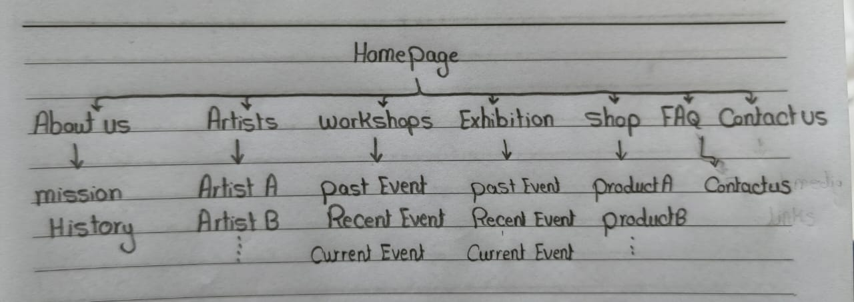

**Wireframe**:

Home page

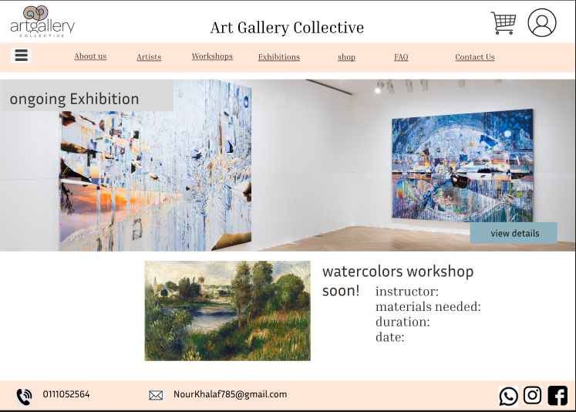

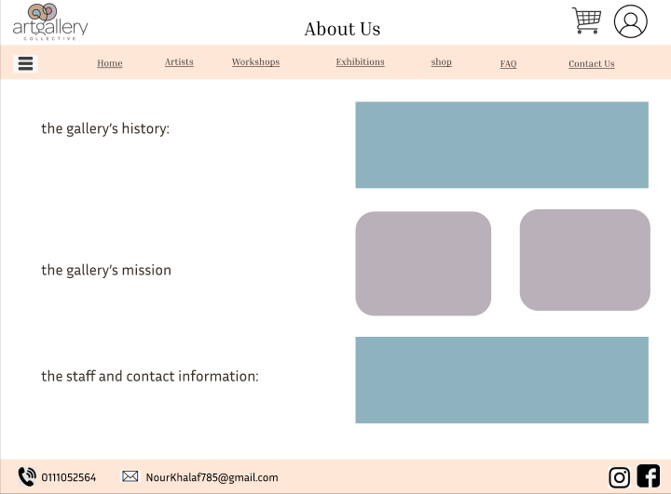About Us page:

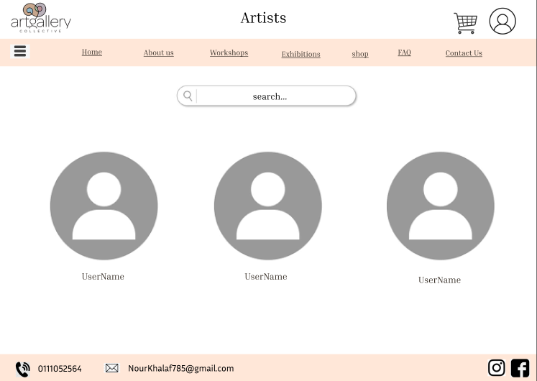Artists Page:

Workshops Page:

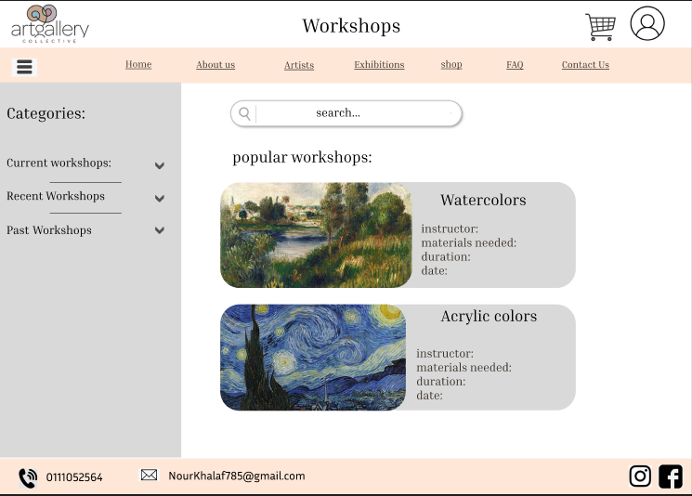

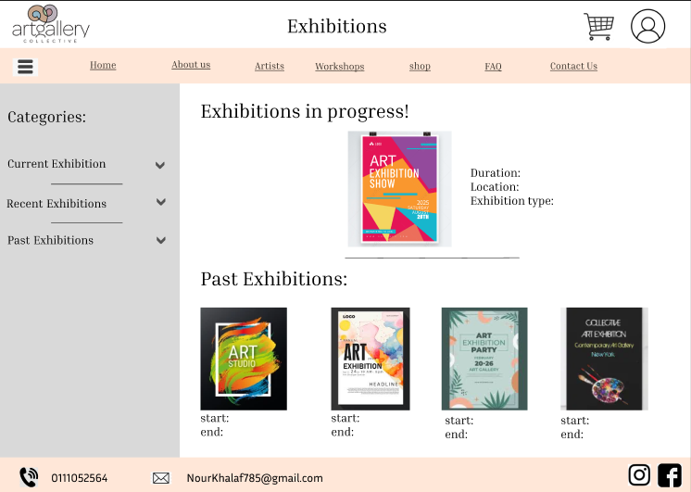Exhibitions:

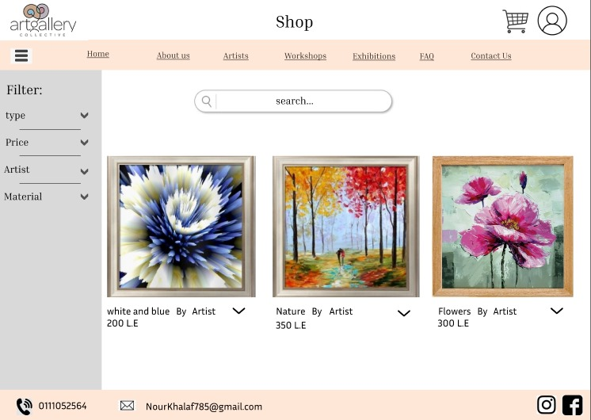Shop page:

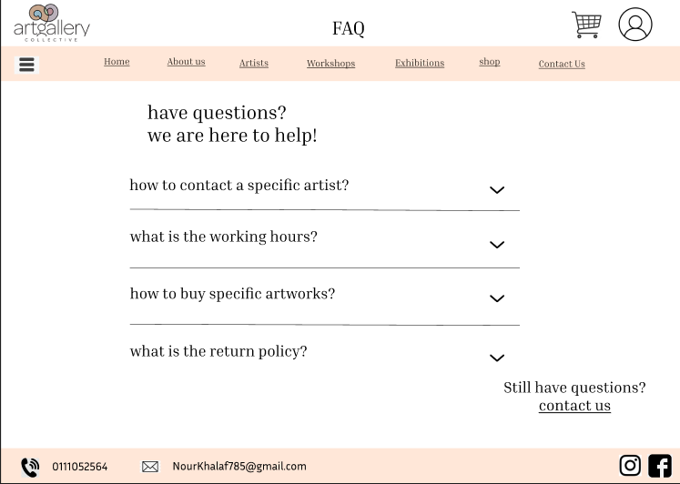FAQ Page:

Contact Us Page:

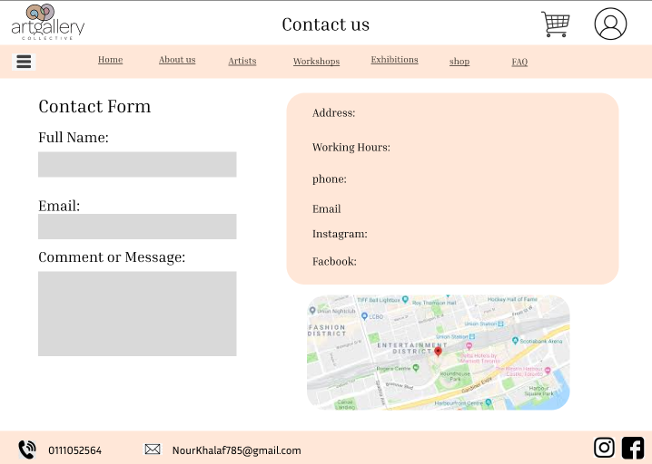

**2.3.3. Part 2: Website design**

**[A] Gestalt Web design principles:**

Home page:

1. the layout is simple and clear
2. each section is visually separated, white space make each section complete and distinct
3. elements are balanced
4. the light background help text and image stand out
5. The hero image of the exhibition and the text (ongoing Exhibition) are connected, the details of coming workshop are grouped, creating connection.
6. Easy for user to identify the area of the exhibition and the workshop
7. The exhibition image and (view details) button are related cause they are close to each other
8. Does not apply
9. Design include moving pictures of ingoing exhibition
10. Do not apply
11. The navigation bar , all its items have the same font
12. Using familiar symbols the user can recognize (shopping cart, Instagram , phone)

About us:

1. Simple layout, clear and avoid unnecessary elements
2. (Mission, History and staff information) are separated , user can perceive each section a a separate complete unit
3. Layout of pictures are symmetrical
4. the light background help text and image stand out
5. (Mission, History and staff information) each title aligned with its corresponding text, creating connection.
6. The header (About us) help user identify the main content area
7. (Mission, History and staff information) each title aligned with its corresponding text, creating connection.
8. Does not apply
9. Does not apply
10. Pictures have a parallel layout, they became related
11. the navigation bar , all its items have the same font
12. Using familiar symbols the user can recognize (shopping cart, Instagram , phone)

Artists:

1. Simple layout, clear and avoid unnecessary elements
2. The user profile pictures, each is individual , helping the user perceive each profile as entity
3. The layout is symmetrical with profile icons aligned horizontally
4. The white background help the icons stand out as main content
5. Each profile picture is connected with its username located below it, clear relationship between the icon and label
6. The content of the page is grouped with the same white color, help distinguish the header and footer from content area.
7. The small space between profile icons and the username create relationship
8. The horizontal alignment of profile icons create continuation.
9. Does not apply
10. The search bar is parallel with the profile icons creating connection, as user will user this bar to search for profiles only
11. Profile icons are similar shapes but each icon have its own account
12. Using familiar symbols the user can recognize (shopping cart, Instagram , phone)

Workshops:

1. The design is clear and well-organized
2. Each workshop is grouped with its own image and description, helping user perceive each workshop as standalone unit
3. The alignment between different workshops create similarity and order, as each box of the workshop have the same structure
4. The white background help the workshop boxes stand out as main content
5. Each workshop have its own image, title and details grouped with the same block, indicate they belong together
6. The content of the page is grouped with the same white color, help distinguish the header and footer from content area
7. There is space between workshops helping user view them as separate units
8. The side bar, contain categories of workshops, each category have a drop down icon. There will be continuation of workshops downward after using the drop down icon
9. Does not apply
10. The alignment of the workshops make them seem related
11. Each box of workshops have similar characteristics
12. Using familiar symbols the user can recognize (shopping cart, Instagram , phone)

Exhibitions:

1. The design is clear and well-organized
2. Each Exhibition is presented in its own visual area.
3. The layout maintain symmetry by centering the main content and aligning exhibition items evenly in a row
4. The white background help exhibition content stand out as main content
5. Each exhibition have an image and a text below it, they are grouped closely together making them connected
6. The (exhibition in progress) and (past exhibitions) are grouped within distinct area, help user understand each area serve different content
7. Proximity between exhibition image and its details
8. The side bar, contain categories of Exhibition, each category have a drop down icon. There will be continuation of Exhibitions downward after using the drop down icon
9. Does not apply
10. The alignment of the Exhibitions make them seem related
11. Each Exhibition have similar characteristics (image, details)
12. Using familiar symbols the user can recognize (shopping cart, Instagram , phone)

Shop:

1. Layout is clean and straightforward. Only necessary items are displayed
2. Each artwork is represented within a boarded box, helping user perceive each artwork as separate complete unit
3. The alignment of artwork items and filter section create balanced order design
4. The white background help the artwork stand out as main focus
5. Each artwork is paired with title, price and artist name which is visually connected
6. The filter section is separated from artwork creating distinct region. Helps user differentiate between filter option and main area
7. The title, price and artist name are placed directly below each artwork, also the spacing between artworks allow each to perceive as individual item
8. The side bar, contain a filter of artworks, each have a drop down icon. There will be continuation of downward items after using the drop down icon
9. Does not apply
10. The displayed artwork are parallel to each other
11. Each artwork have the same characteristics (same image size and the details displayed) creating similarity
12. Using familiar symbols the user can recognize (shopping cart, Instagram , phone)

FAQ:

1. Clean and simple layout that avoid clutter
2. Each question is separated by a horizontal line creating sense of closer between every question
3. The layout is balanced, the questions listed symmetrically in center of page
4. The white background help the FAQ questions stand out as main focus.
5. Each FAQ item is connected by alignment and spacing, user will notice that each question is a unit in FAQ section.
6. The FAQ section is grouped with a clear white space area, which distinguish between navigation bar and footer.
7. The questions and the drop down icons are placed close together creating relationship
8. The dropdown icon beside every question will create a continuation of answers downward after clicking on it.
9. Does not apply
10. The questions are aligned in parallel
11. The navigation bar, each section have the same characteristics (same font and size and functionality)
12. Using familiar symbols the user can recognize (shopping cart, Instagram , phone)

Contact us:

1. Design is simple and well-organized
2. The contact form, contact information and map are separated creating sense of closure
3. The layout of the contact form on the left and the contact information on the right is balanced
4. The color of contact information box contrasts with the white background of the page, making it stand out
5. Each label and its input box in contact form is grouped closely together, helping the user understand the relationships between them
6. The contact form, contact information and map create regions, user can differentiate between them clarifying the page layout
7. The map is placed under contact information, referring that they are related. In addition to each label and its input box in contact form is grouped closely together, helping the user understand the relationships between them
8. Does not apply
9. Does not apply
10. The contact form input boxes are parallel , referring that they belong to the same region
11. The navigation bar, each section have the same characteristics (same font and size and functionality)
12. Using familiar symbols the user can recognize (shopping cart, Instagram , phone)

**[B] Deployment of other design concepts:**

Screen resolution: 1440 x 1024

Color palette: using Adobe Color Wheel CC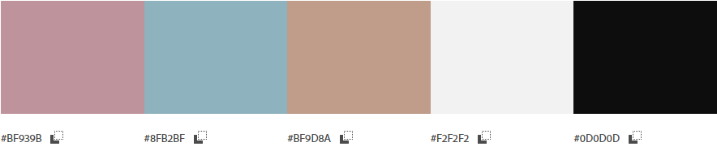

Minimum contrast accepted for accessibility: 4.5:1

Front-end developing tools:

* HTML: provide the basic structure of the website, organize content and define elements.
* CSS: control the appearance and customization of styles.
* JavaScript: allowing dynamic contact and animated graphics.

Contact management system: using word press: create, manage and modify content.

Backend developing tools:

* PHP: develop dynamic page

Metrics to use for measuring performance of website:

* Measuring web page change
* Content rating by visitors

**HTML5 page structure:**

Homepage: 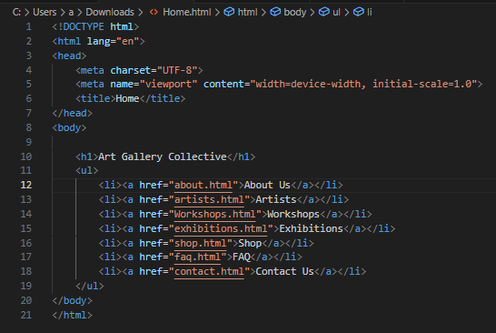

About us:

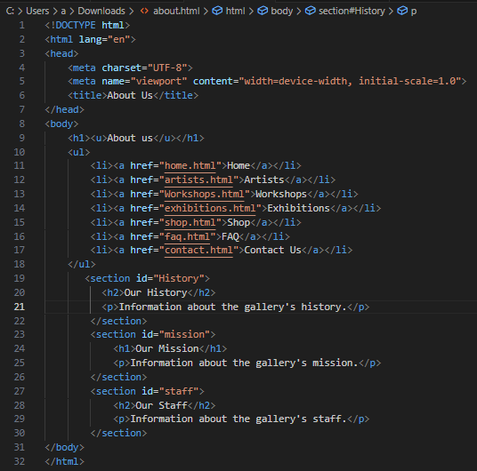

Artists: 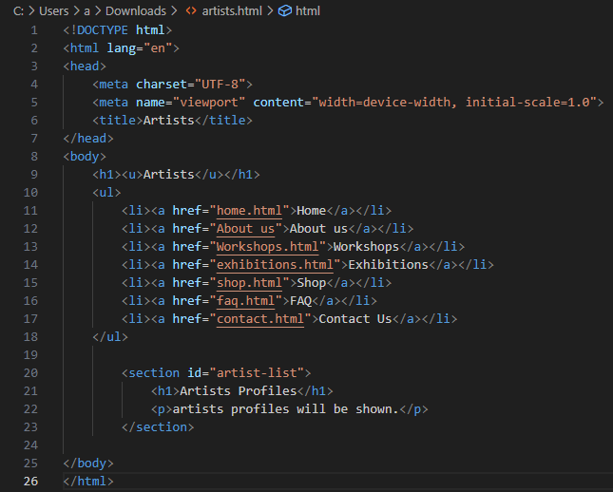

Workshops:

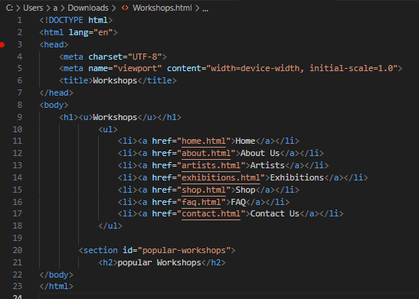

Exhibitions: 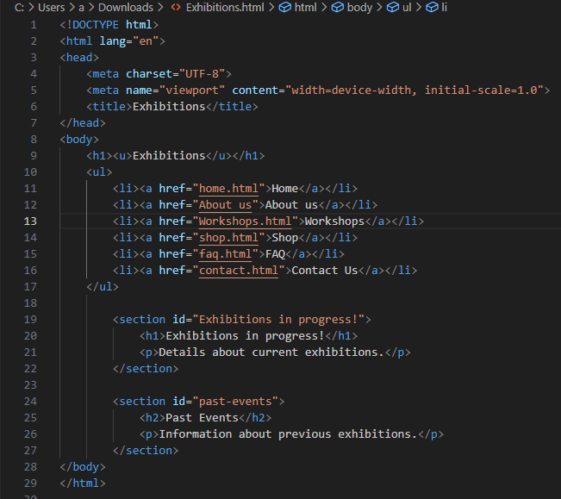

Shop: 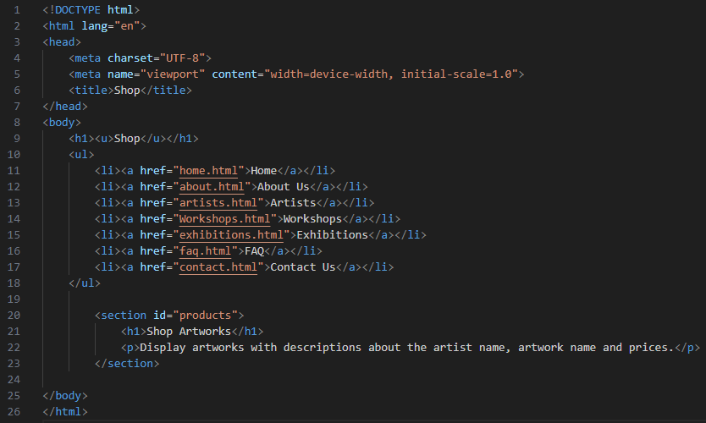

FAQ: 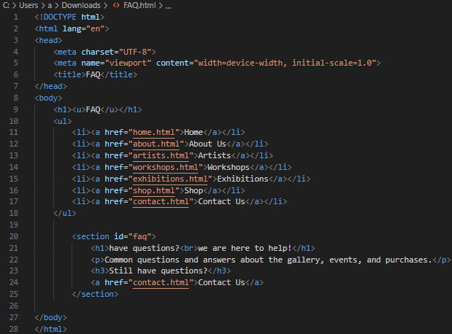

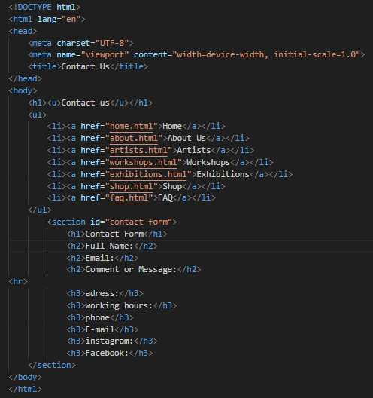Contact us:

**References:**

O'reilly, T. (2009). *What is web 2.0*. " O'Reilly Media, Inc.".

Nath, K., Dhar, S., & Basishtha, S. (2014, February). Web 1.0 to Web 3.0-Evolution of the Web and its various challenges. In *2014 International Conference on Reliability Optimization and Information Technology (ICROIT)* (pp. 86-89). IEEE.‏